NAME: Kartikey Singh | REGISTRATION NUMBER: 12216766
ROLLNO: 23

CASE NO: | RECOMMENDATIONS (Yes/No) | INSIGHTS DISCUSSION (Mention briefly)
CASE1 | YES | In the pursuit of increasing sales, companies often turn to strategies like offering discounts and analyzing user acquisition. Based on our insights, we recommend displaying regional sales data in a rank-wise format for each year. This approach will allow businesses to see how different regions perform relative to one another, helping to identify growth opportunities. Additionally, knowing the last sold date of each product is crucial; it not only aids in inventory management but also helps in understanding sales trends over time.
CASE2 | YES | The Digital Ads Sales dataset offers a fascinating glimpse into quarterly sales data across various states, regions, and sub-regions, revealing important insights into customer behavior and performance. By analyzing this dataset, we can uncover how sales trends fluctuate across different regions over time, which is crucial for understanding local market dynamics. Additionally, it allows us to identify which customer types—be it Non-Profit, Private, or Government—generate the highest sales in each state and region, enabling businesses to tailor their marketing strategies more effectively.
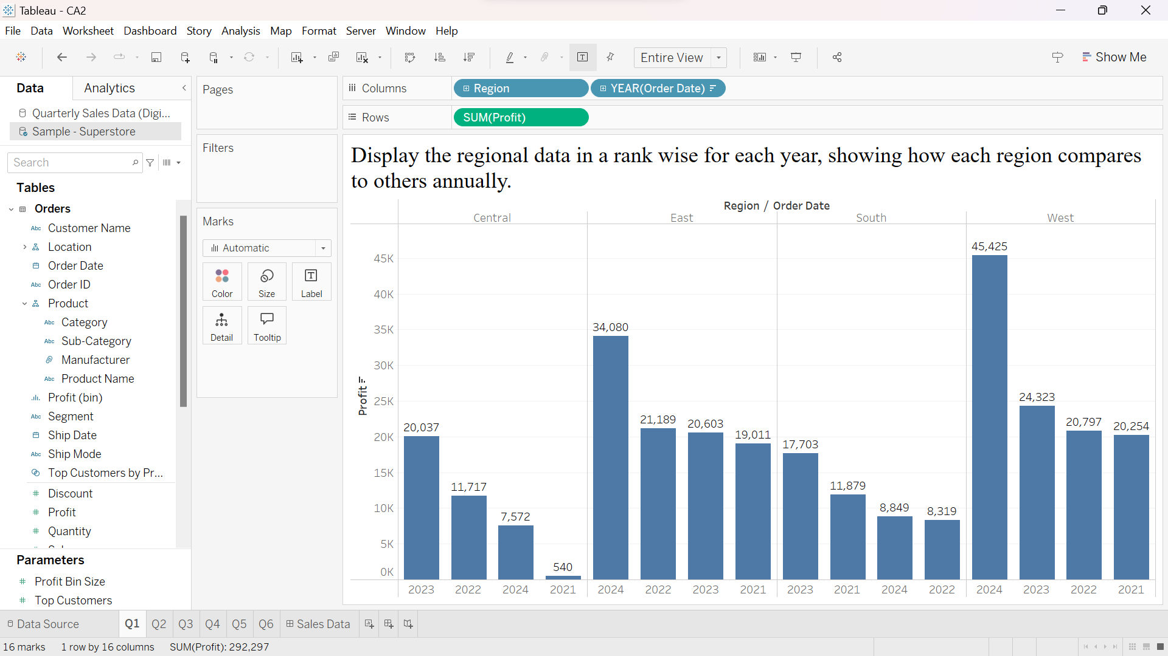
In West Region sales were highest

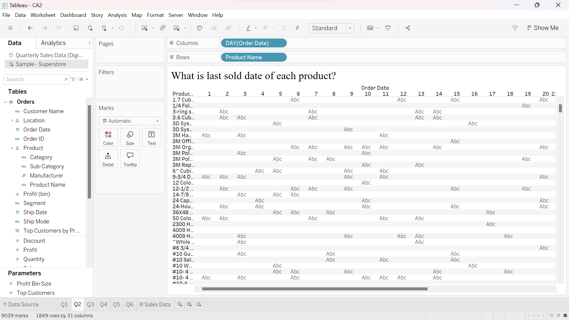

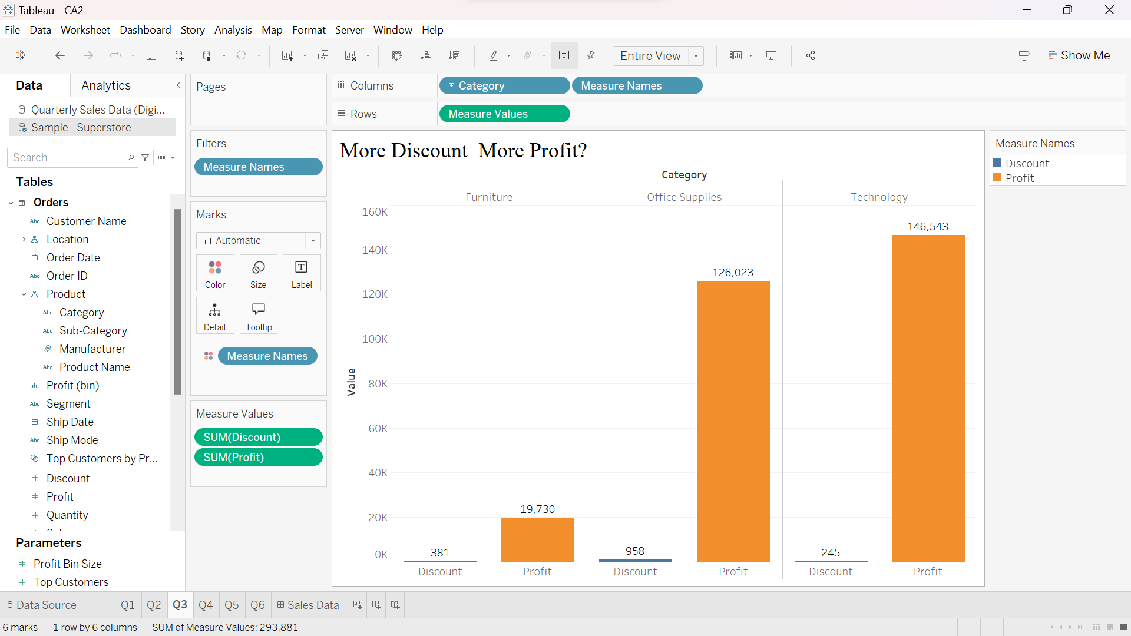
Yes

